.

📘 Project Documentation — Brain Tasks Application Deployment (End-to-End)

1. Project Overview
The objective of this project was to deploy a React-based Brain Tasks Application using a complete CI/CD pipeline and AWS infrastructure. The final application runs in Amazon EKS, updated automatically using AWS CodePipeline & CodeBuild, with container images stored in Amazon ECR.

2. Architecture
GitHub → CodePipeline → CodeBuild → ECR → EKS Cluster → Application Service (LoadBalancer + ASG)

3. Tools & Technologies Used

AWS Services
- ECR – Docker image storage
- EKS – Kubernetes cluster for scalable deployment
- EC2 – Bastion / kubectl node
- CodeBuild – Builds Docker image, pushes to ECR, deploys to EKS
- CodePipeline – Automates CI/CD
- CloudWatch – Logs and monitoring
- IAM – Access roles and permissions

Other Tools
- Docker
- Kubernetes (kubectl)
- Git & GitHub
- NGINX (used inside Docker container)

4. Step-by-Step Implementation

4.1 Application Setup
- Cloned the React application repo:
- https://github.com/Vennilavan12/Brain-Tasks-App.git
- Installed dependencies and verified application runs on port 3000.

4.2 Dockerization
A production-ready Dockerfile was created:
FROM public.ecr.aws/nginx/nginx:stable-alpine
RUN rm -rf /usr/share/nginx/html/*
COPY dist /usr/share/nginx/html
EXPOSE 80
CMD ["nginx", "-g", "daemon off;"]

Steps performed:
- Built the application using npm run build.
- Built the Docker image.
- Tested locally using Docker.

4.3 Amazon ECR Setup
- Created an ECR repo: braintasks-app
- Logged into ECR using CodeBuild
- Pushed the Docker image manually & later automated via pipeline

4.4 Amazon EKS Cluster Setup
- Created EKS Cluster: braintasks-cluster
- Node group created and attached
- Configured kubectl on EC2 admin node
- Updated aws-auth ConfigMap to grant permissions

4.5 Kubernetes Deployment Files

deployment.yaml
- Deploys the container image from ECR
- Runs replica sets

service.yaml
- Exposes the app via LoadBalancer → accessible publicly

4.6 appspec.yml for Deployment Automation
Used by build process (not CodeDeploy) to define deployed Kubernetes files:
version: 0.0
Resources:
- Kubernetes:
Manifest:
- deployment.yaml
- service.yaml

4.7 Custom Deployment Script (deploy.sh)
Because CodeDeploy EKS is not available for new accounts, I created a custom deployment automation script:
#!/bin/bash
set -e

MANIFESTS=$(yq e '.Resources[0].Kubernetes.Manifest[]' appspec.yml)

aws eks update-kubeconfig --name braintasks-cluster --region us-east-1

for FILE in $MANIFESTS; do
kubectl apply -f $FILE
done

echo "Deployment completed successfully."
This script automatically:
- Updates kubeconfig
- Applies deployment & service files
- Rolls out changes to EKS

4.8 CodeBuild Setup
buildspec.yml
version: 0.2
env:
variables:
AWS_DEFAULT_REGION: "us-east-1"

phases:
pre_build:
commands:
- echo Logging into Amazon ECR...
- aws ecr get-login-password --region $AWS_DEFAULT_REGION | docker login --username AWS --password-stdin 968295617741.dkr.ecr.$AWS_DEFAULT_REGION.amazonaws.com

build:
commands:
- echo Building Docker image...
- docker build -t braintasks-app .
- docker tag braintasks-app:latest 968295617741.dkr.ecr.$AWS_DEFAULT_REGION.amazonaws.com/braintasks-app:latest

post_build:
commands:
- echo Pushing Docker image...
- docker push 968295617741.dkr.ecr.$AWS_DEFAULT_REGION.amazonaws.com/braintasks-app:latest
- chmod +x deploy.sh
- ./deploy.sh

artifacts:
files: []
✔ Automatically builds, pushes, and deploys the updated image
✔ No manual steps required after pushing to GitHub
✔ Fully operational CI/CD pipeline

4.9 CodePipeline Setup
Pipeline stages:

Stage 1: Source
- Provider: GitHub repository
- Activated on push events (webhooks)

Stage 2: Build
- Runs CodeBuild
- Creates latest Docker image
- Deploys automatically using kubectl

Stage 3: Deploy
(Because CodeDeploy EKS not enabled)
- Deployment handled inside build stage using deploy.sh

4.10 Monitoring

Using CloudWatch:
- Build logs from CodeBuild
- Pipeline execution logs
- EKS cluster logs
Snapshots of Project
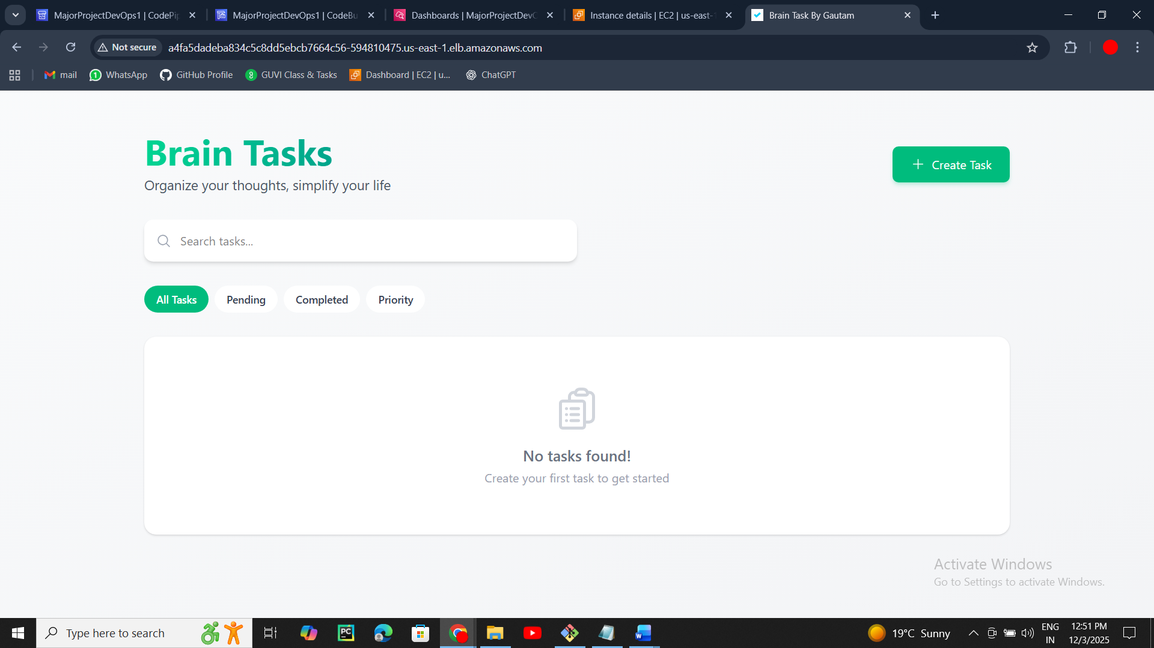
Load Balancer URL: (http://a4fa5dadeba834c5c8dd5ebcb7664c56-594810475.us-east-1.elb.amazonaws.com/)
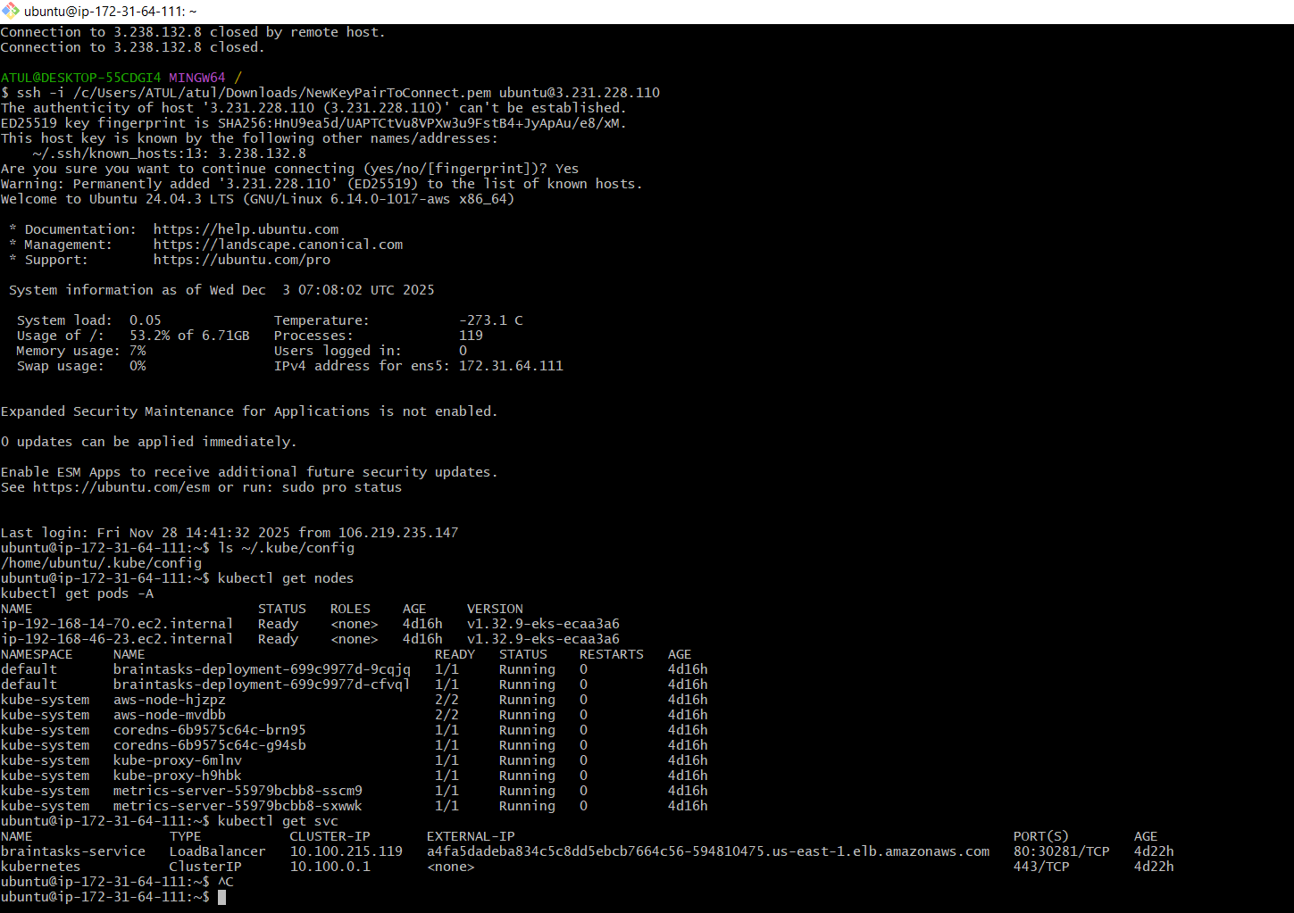
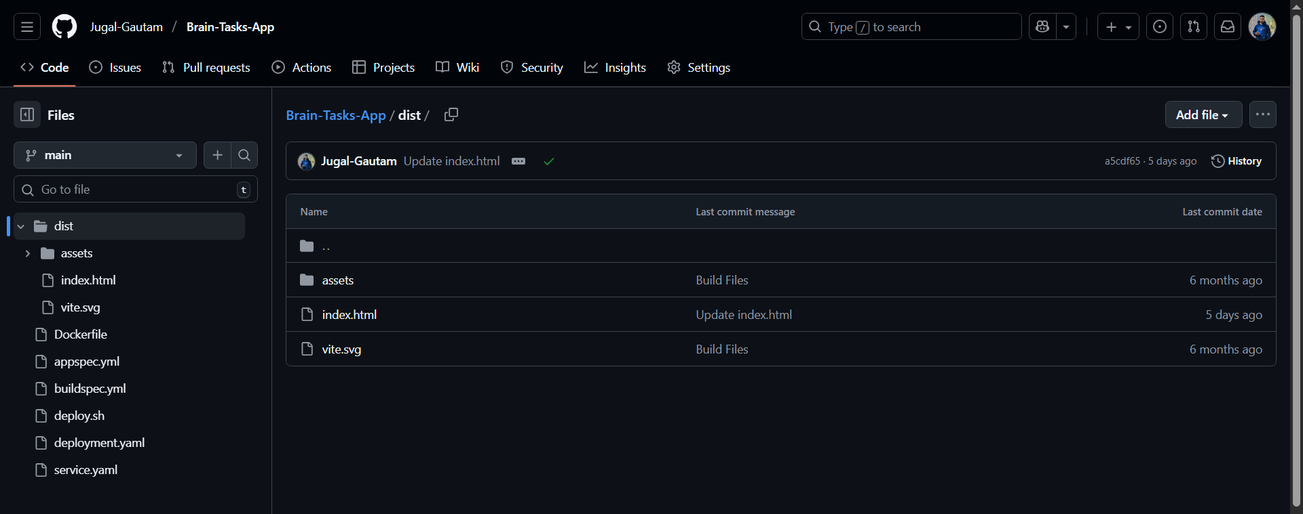
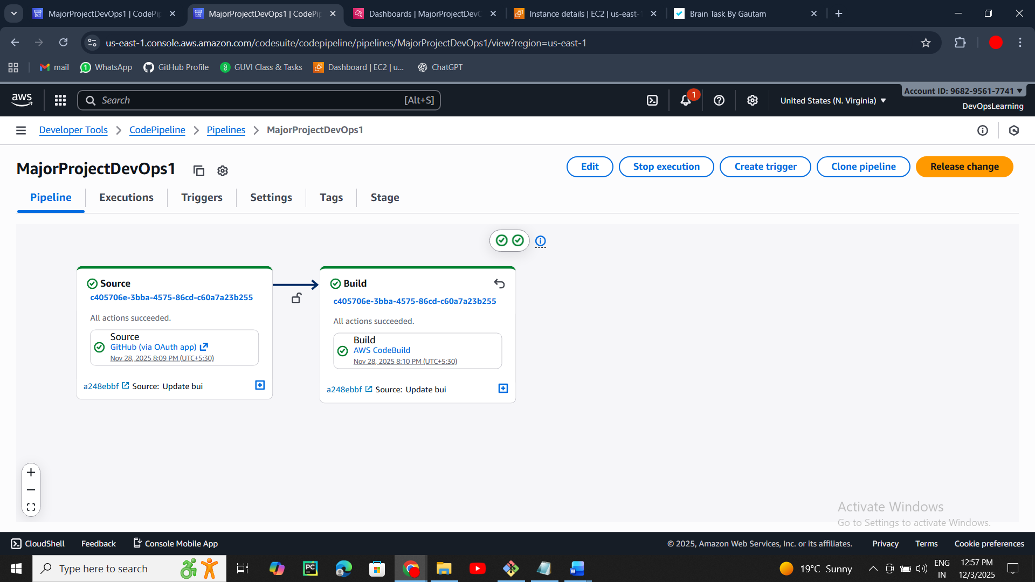
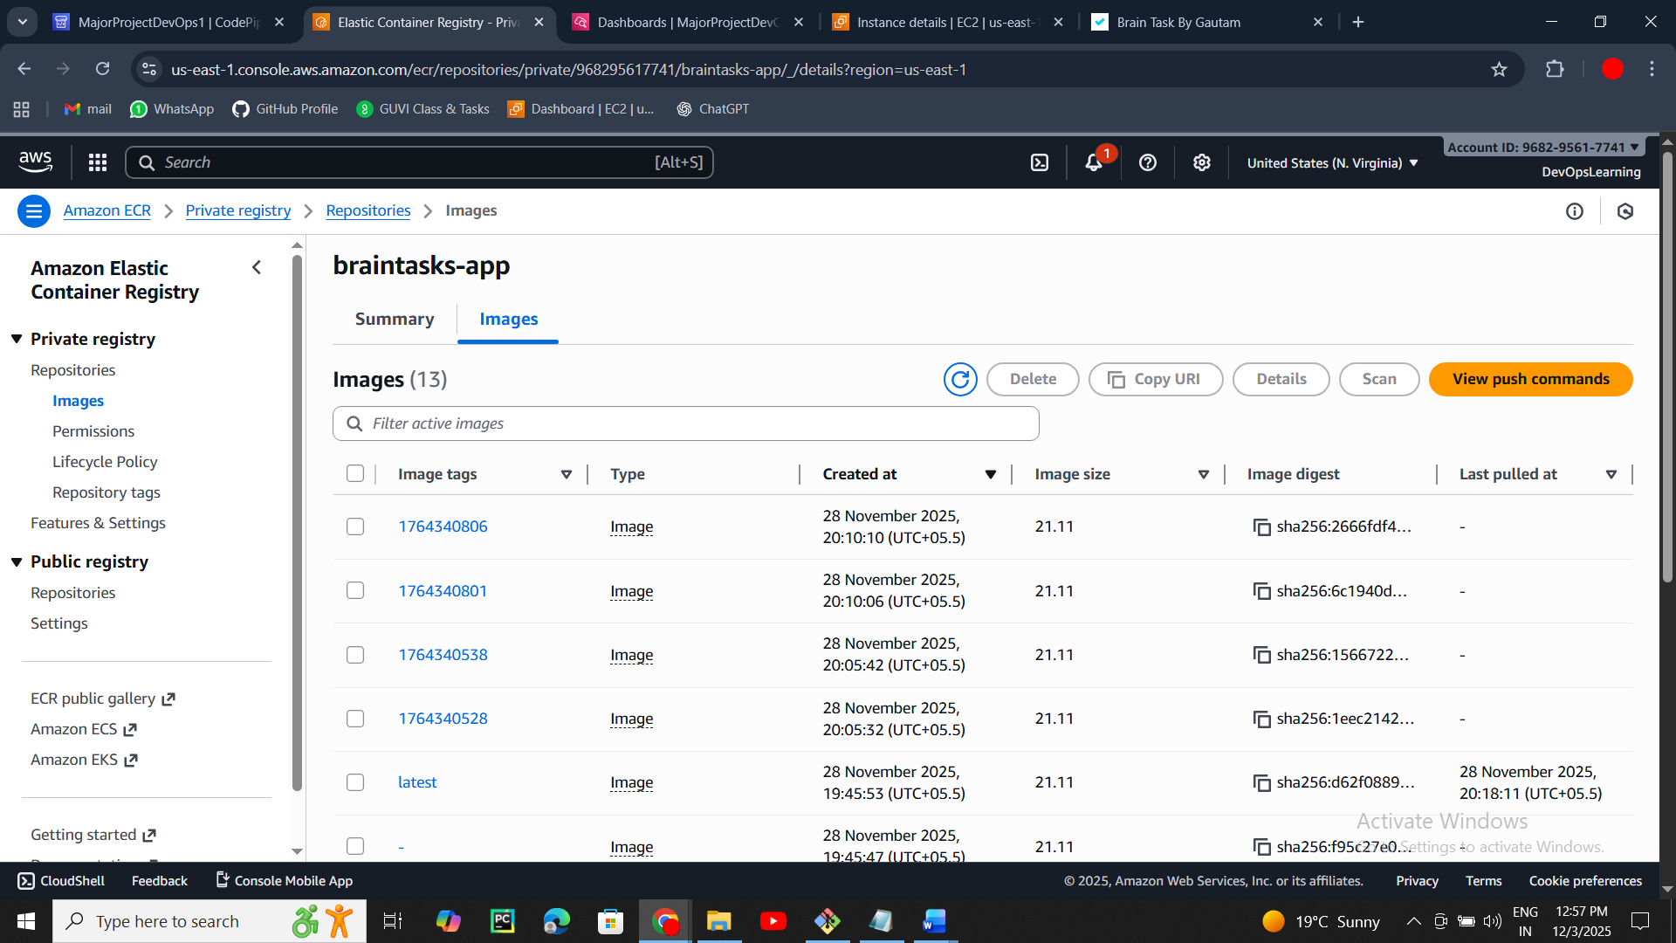
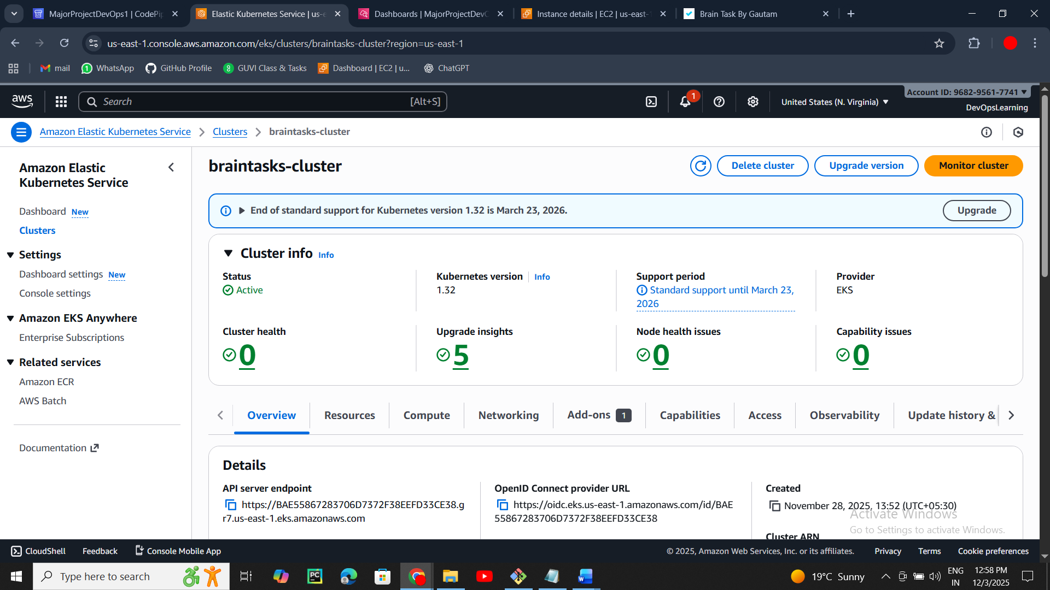
Note* Application has been stopped due to budget constraints

Documented By
Jugal Gautam
03/12/2025

